悠遊國際港都 金建旅行社
Kaohsiung City Tour
by Golden Founders Travel Services Corp.
Time | PM13:30~20:30
Departure Place | 蓮潭會館  Garden Villa
內容
Tour Plan | 全程時間約為7小時  迎接貴賓→高雄十大景致 1.國家世運主場館/生態公園→左營蓮池潭→鐵道紀念館→2.西子灣夕照中山大學/英國領事館→真愛碼頭搭乘觀光遊港輪 於船上享用自助餐（航行時間約2hr ）  Tour time: About 7 hours  Depart from Hotel→World Games Stadium/ Ecological Park →Lotus Pond (Zuoying)→ Railway Museum → Sizihwan Sunset / British Consulate at Takou→Pier 12 (Love Pier) →Kaohsiung Harbor cruise (about two hours including dinner buffet on the boat).
Harbor Cruise  Introduction | 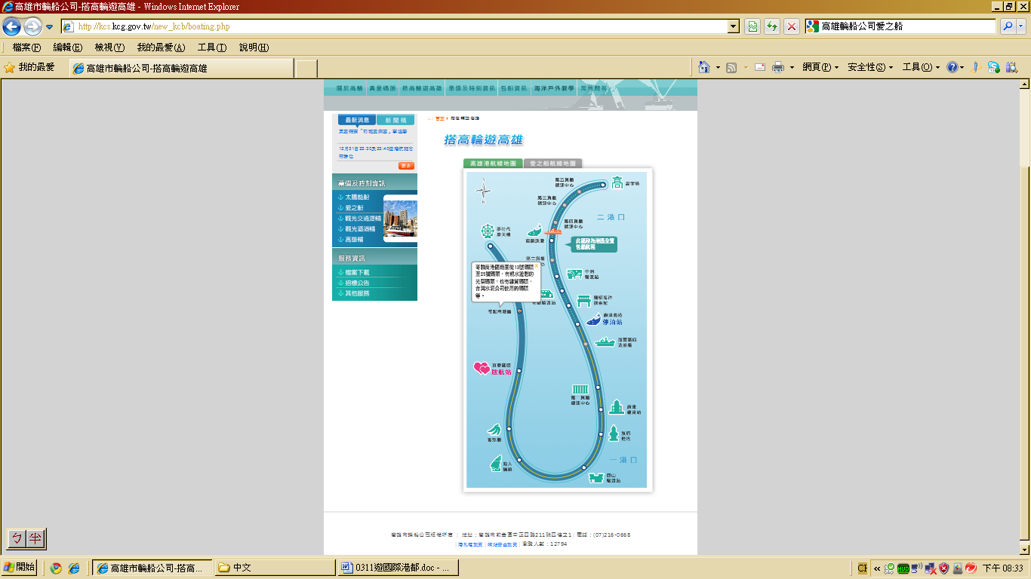  真愛碼頭：高雄市鹽埕區公園二路11號 TEL: 2160668 ext. 603  備註說明:遊港船為遊覽大半個高雄內港，經由高雄港的第一港口主航道行駛，沿路可遊覽苓雅商港區、蓬萊商港區、中島商港區、第一貨櫃儲運中心、海軍基地、第七船渠，終點折返點在旗津漁港觀光漁市港口，船上有導覽人員，幫助您了解其觀光景點。  Love Pier’s Address: Yancheng District, Kaohsiung City Park Road 11  Remarks: The Harbor Cruise will cover almost half of Kaohsiung Harbor. It departs from the Love Pier and goes along the main channel of Kaohsiung Harbor. On the way, you can see Lingya and Penglai commercial ports, Middle Island Commercial Center, the first container storage and transportation center, naval base, and the seventh ship channel. At the end, you will back to Love Port. The English tour guide will accompany you all the way through.

